Advance Excel Assignment 5

1. How many types of conditions are available in conditional formatting on Excel?

These can be broadly categorized under 5 different categories –Background Color Shading (of cells)

* Foreground Color Shading (of fonts)
* Data Bars.
* Icons (which have 4 different image types)
* Values

Wherein “Highlighted Cell Rules” section has mainly around 7 Different rules.

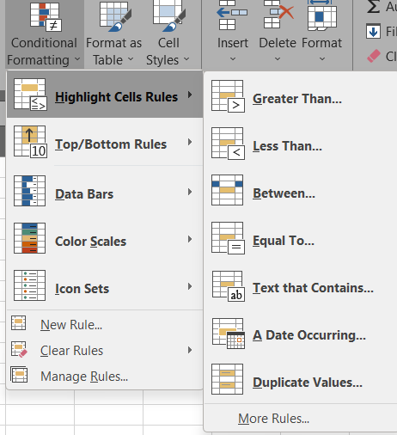

1. How to insert border in Excel with Format Cells dialog?
   * Select one or more cells to which you'd like to add borders.
   * Open the Format Cells dialog box by doing one of the following: ...
   * In the Format Cells dialog box, switch to the Border tab and choose the line style and color first. ...
   * When done, click OK
2. How to Format Numbers as Currency in Excel?
   * Select the cells that you want to format and then, in the Number group on the Home tab, click the down arrow in the Number Format box.
   * Choose either Currency or Accounting
3. What are the steps to format numbers in Excel with the Percent style?
   * On the Home tab, in the Number group,
   * click the icon next to Number to display the Format Cells dialog box.
   * In the Format Cells dialog box, in the Category list, click Percentage.
   * In the Decimal places box, enter the number of decimal places that you want to display
4. What is a shortcut to merge two or more cells in excel?
   * Merge Cells: ALT H+M+M
5. How do you use text commands in Excel?
   * Text is the a type of formula hence to invoke any formula in Excel –
     + We use ‘=’ Equals sign

Examples of text commands –

|  |  |
| --- | --- |
| =TEXT(TODAY(),**"DDDD"**) | Today’s day of the week, like Monday |
| =TEXT(TODAY(),"MM/DD/YY") | Today’s date in MM/DD/YY format, like 03/14/12 |

Source: [Microsoft TEXT function](https://support.microsoft.com/en-us/office/text-function-20d5ac4d-7b94-49fd-bb38-93d29371225c%23:~:text=Select%20the%20column%2C%20or%20range,function%20to%20add%20them%20back.)

